A.1
CREATE DATABASE SalesDB;
USE SalesDB;
CREATE TABLE SalesData (
SaleID INT PRIMARY KEY,
Salesperson VARCHAR(50) NOT NULL,
Department VARCHAR(30) NOT NULL,
SaleDate DATE NOT NULL,
Amount DECIMAL(10,2) NOT NULL
);
INSERT INTO SalesData
(SaleID, Salesperson, Department, SaleDate, Amount)
VALUES
(1, 'Aarav Shah', 'Electronics', '2026-01-05', 50000.00),
(2, 'Priya Patil', 'Furniture', '2026-01-08', 40000.00),
(3, 'Rohan Desai', 'Electronics', '2026-01-12', 65000.00),
(4, 'Sneha Joshi', 'Furniture', '2026-01-15', 55000.00),
(5, 'Karan Mehta', 'Electronics', '2026-02-05', 65000.00),
(6, 'Meera Kulkarni', 'Furniture', '2026-02-10', 30000.00),
(7, 'Neha Shah', 'Clothing', '2026-02-12', 45000.00),
(8, 'Aman Verma', 'Clothing', '2026-02-18', 45000.00),
(9, 'Divya More', 'Electronics', '2026-03-03', 80000.00),
(10, 'Rahul Sharma', 'Furniture', '2026-03-06', 60000.00),
(11, 'Isha Nair', 'Clothing', '2026-03-10', 70000.00),
(12, 'Om Jadhav', 'Electronics', '2026-03-14', 55000.00);
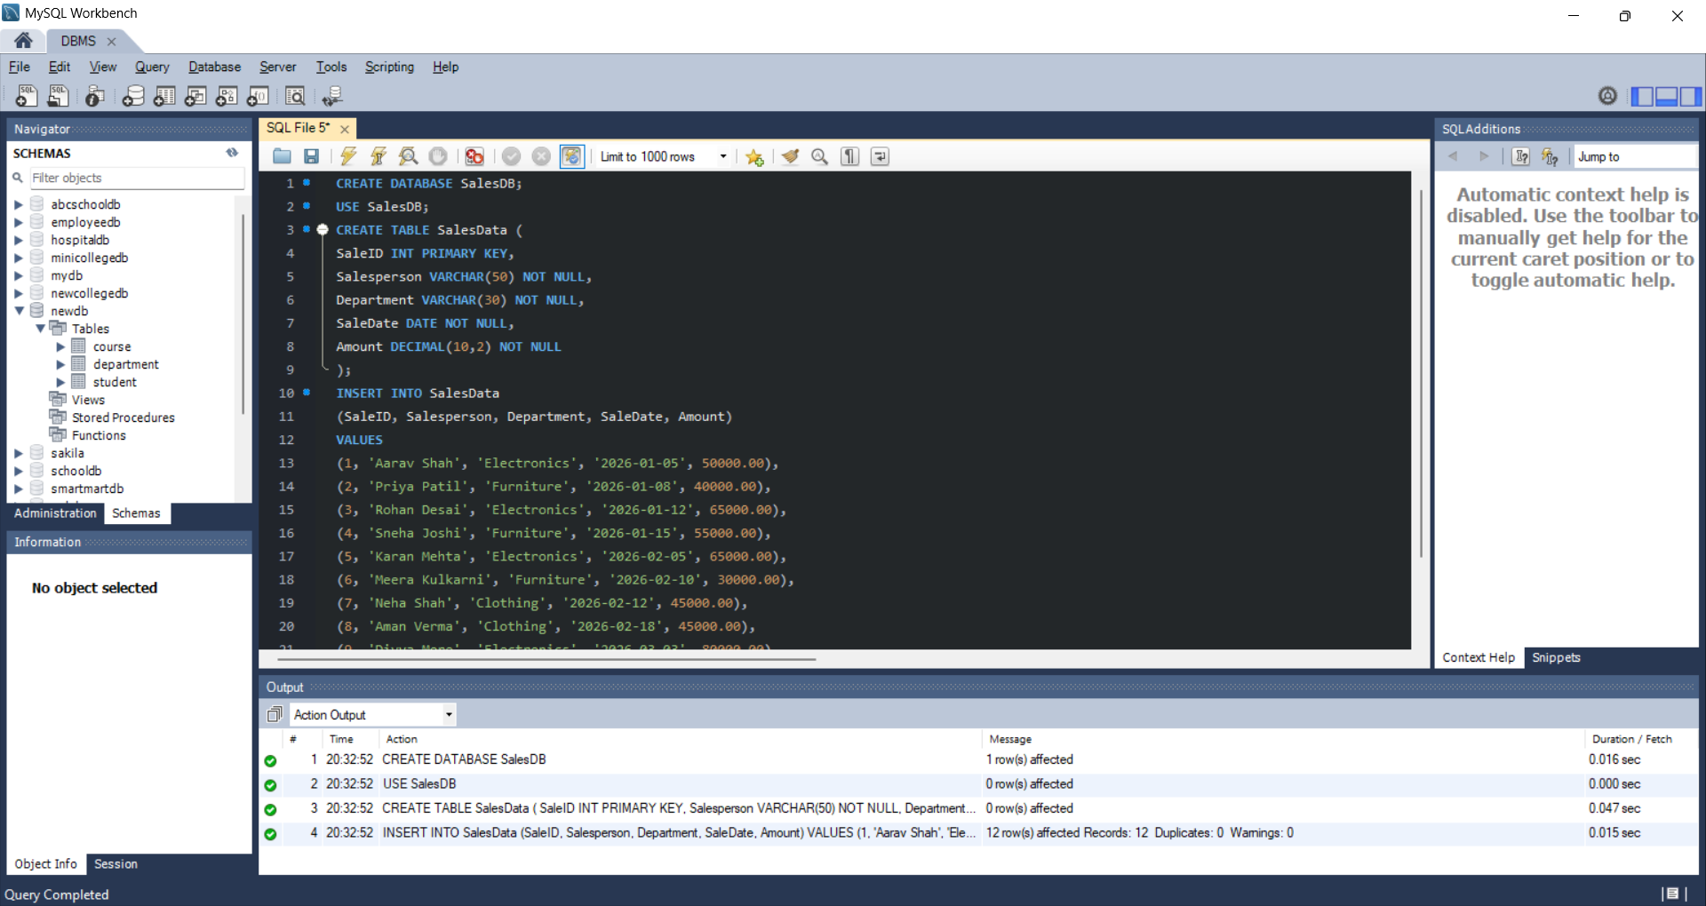

A.2
SELECT
Salesperson,
Department,
Amount,
ROW_NUMBER() OVER (
ORDER BY Amount DESC, SaleID ASC
) AS SalesRowNumber
FROM SalesData;
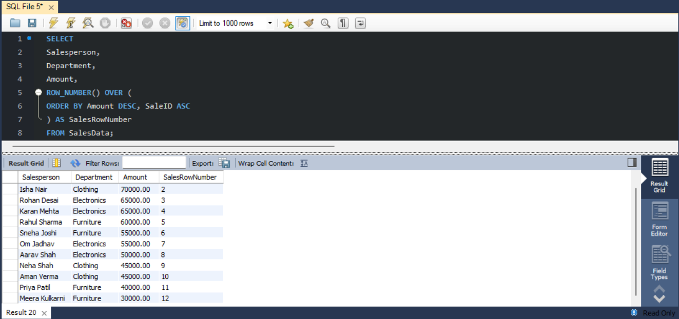

A.3
SELECT
Salesperson,
Department,
Amount,
RANK() OVER (
ORDER BY Amount DESC
) AS SalesRank
FROM SalesData;
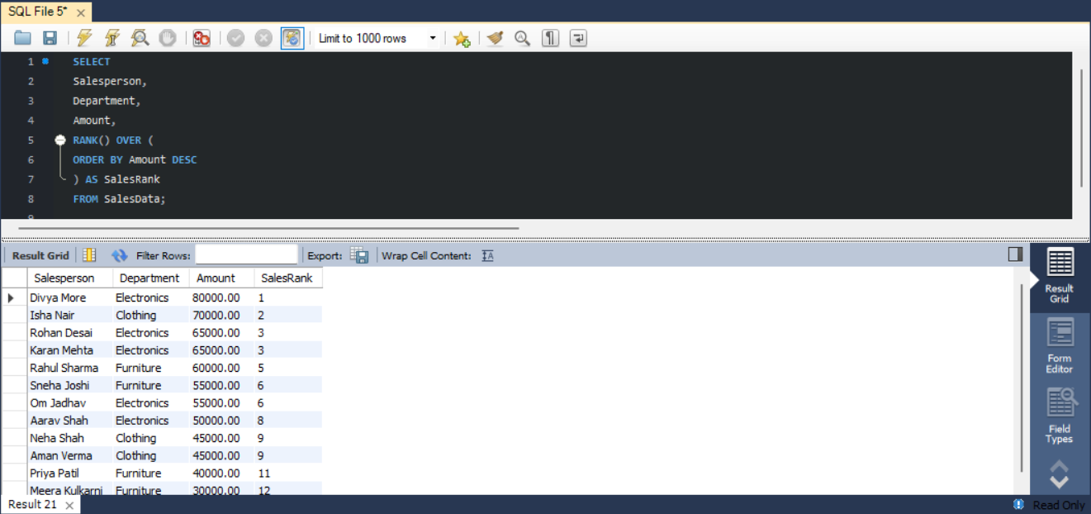

A.4
SELECT
Salesperson,
Department,
Amount,
RANK() OVER (
PARTITION BY Department
ORDER BY Amount DESC
) AS DepartmentRank
FROM SalesData
ORDER BY Department, DepartmentRank;
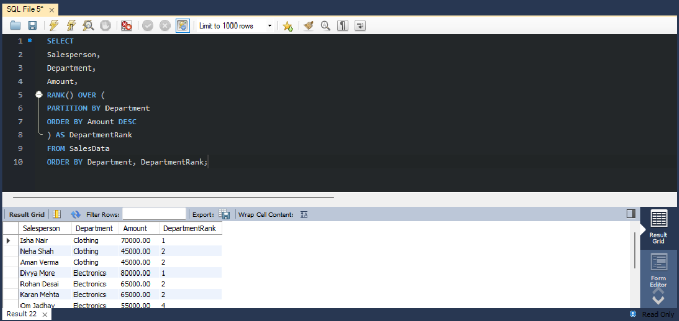

A.5
SELECT
SaleID,
Salesperson,
SaleDate,
Amount,
SUM(Amount) OVER (
ORDER BY SaleDate, SaleID
ROWS BETWEEN UNBOUNDED PRECEDING AND CURRENT ROW
) AS RunningTotal
FROM SalesData
ORDER BY SaleDate, SaleID;
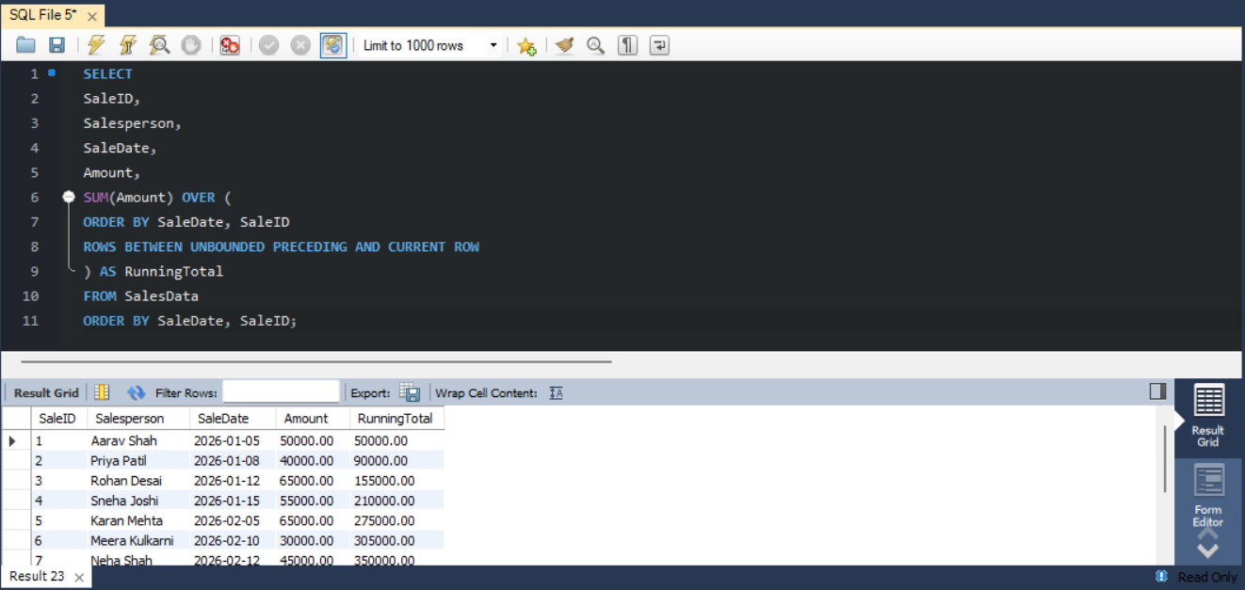

A.6
SELECT
Salesperson,
Department,
Amount
FROM (
SELECT
Salesperson,
Department,
Amount,
ROW_NUMBER() OVER (
PARTITION BY Department
ORDER BY Amount DESC, SaleID ASC
) AS DepartmentRowNumber
FROM SalesData
) AS DepartmentSales
WHERE DepartmentRowNumber = 1;
